RESUME
Mr. Niranjan Karanth M N  S/O Nagesh Murthy MN  Melinamane, thalagodu Village  Balehole post, Mudigere TQ  Chikkmagalur Dist.  EmailID: karanthmn1612@gmail.com  Mobile No: +91 8073150554 | 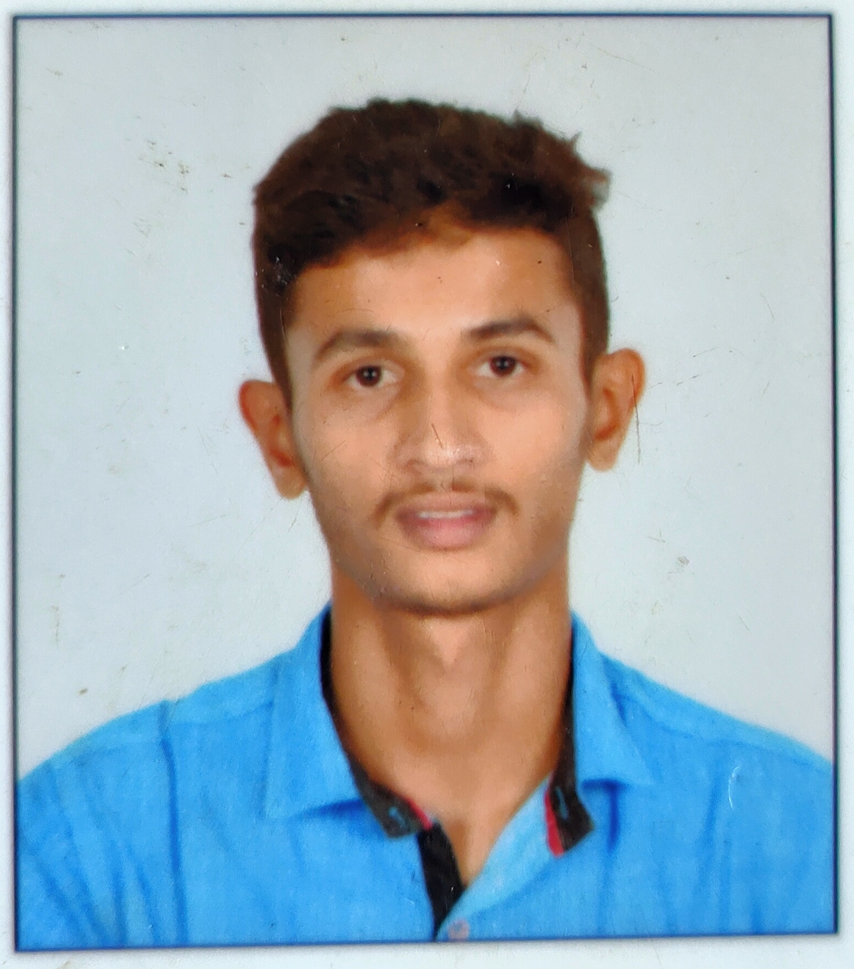
CAREER OBJECTIVE

I am looking forward to an opportunity where I can utilize my skills in constituting effectively to the success of the organization and further improvement of my personal skills. To acquire a good position in financial sector where I could utilize my good analytical and quick calculation skills for the profitability of the organization.

 | Course | Institution | Board/University | Year | Percentage of Marks
1 | B.Sc. | S.D.M. College Ujire | Mangalagangothri Mangalore University. | 2016-18 | 72.47%
2 | PUC | S.D.M P.U. College Ujire | Department of  Pre-university Education, Karnataka | 2014-16 | 69.33%
3 | SSLC | Sri Sadguru English Medium High School, Basrikatte | Karnataka Secondary Education Examination Board | 2011-14 | 74.24%
ACADEMIC QUALIFICATION

- Working at Infosys Ltd since 3.5 years as Software Engineer. Working mainly on ReactJs and React Native since past 3 years. Also worked on Python, Jquery, MongoDB, SQL DB, Jest, Redux, Node.Js and linux.
- Worked on Topology project as a React Developer since 3 years. So have well hands on experience in front end technologies.

EXTRA CURRICULAR ACTIVITIES
- Completed workshop on Microsoft Excel 2013 held at SDM IT College, Ujire.
- Attended Guest Lecture Programs in chemistry, Physics and Mathematics.
- Attended some of the best training programs based on Personality development, skill development, study skills, motivation for success, RSS Training Camp etc.,
- Participated in inter college spot painting, face painting, pencil sketch competitions.
- Learning Indian Classical Music through regular classes.
- Participated in Singing Competitions like SaReGaMaPa, Sing Dil Se, KJ Motion Pictures Audition etc., and won prizes.

CERTIFICATIONS

- Completed Python Programming, RDBMS, Windows Administration, Cloud Computing, MongoDB Database trainings in Infosys.
- Completed and learnt DataBase & SQL DataBase, L1 Junior Tester Certifications in Infosys.
- Completed and learnt The Complete Java Programming course with certification in Udemy.
- Completed and learnt Web Design for web developers’ course and Modern HTML and CSS course with certification in Udemy.
- Completed and learnt The Complete JavaScript Course 2021 with certification in Udemy.
- Completed and learnt The Complete Node.js Course with certification in Udemy.
- Completed and learnt The Complete React.js and Redux Developer Course with certification in Udemy.
- And now learning C++ Programming, React Native and Ultimate AWS Certified Solutions Architect Associate 2021 in Udemy.
- And created many Real time web applications using JavaScript, React.js, especially in Node.js.

SHORT TERM CERTIFICATE COURSE
 | Tittle | Year | Department
1. | Certificate in Basic Managerial Skills | 2016-17 | Department of Commerce  SDM College, Ujire.
2. | Certificate in Literary translation | 2016-17 | Department of English  SDM College, Ujire.
3. | Certificate in Adobe photo shop | 2017-18 | Department of Computer Science  SDM College, Ujire.
4. | Certificate in Adobe photo shop | 2017-18 | Department of Computer Science  SDM College, Ujire.
PERSONAL INTERESTS
- Interested in Reading Books and Novels.
- Interested in Watching Inspirational Videos and interested in learning computer programs.
- Interested in Drawings, Singing and Games (volley ball, cricket, Carom).
- Interested in Paintings, Pencil Sketch etc.,
- Interested in Clay Modeling.
- Interested in coding.

LANGUAGE PROFICIENCY:

LANGUAGE | READ | WRITE | SPEAK
Hindi | ✓ | ✓ | X
Kannada | ✓ | ✓ | ✓
English | ✓ | ✓ | ✓
Sanskrit | ✓ | ✓ | ✓
PERSONAL PROFILE
Name: Niranjan Karanth M N
Father Name: Nagesh Murthy M N
Date of Birth: 27/10/1998
Gender: Male
Linguistic Proficiency: Kannada, English, Hindi
Nationality: INDIAN
Marital Status: Single
Religion: Hindu

DECLARATION
I hereby declare that all the information that I have provided is true to the best of my knowledge. I will be glad to provide further details, if required.

Place: Bangalore Signature
Date: 07/09/2022 (Niranjan Karanth M N)

